QUESTION 2 : Read 2 numbers from the user. If these numbers are greater than zero then display the sum of these numbers. (Didn’t do Question one, couldn’t understand it)

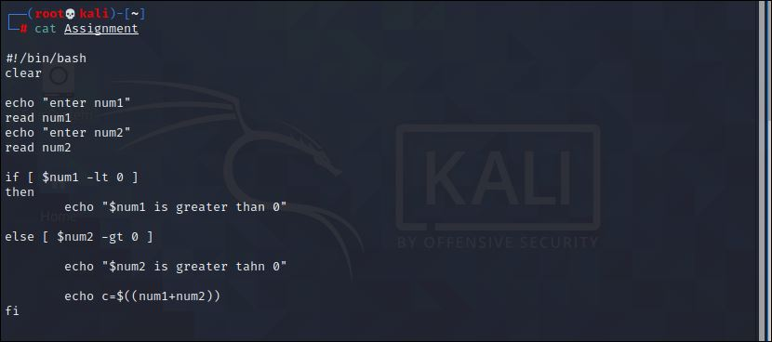

Output :

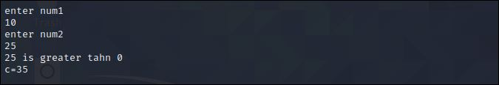

QUESTION 3 : Read the name & password of the user. Check whether the username is DAD and password is 111 and give appropriate messages

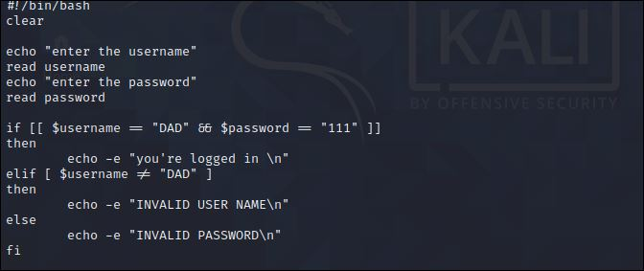

Output :

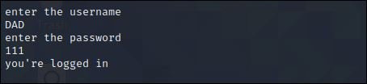

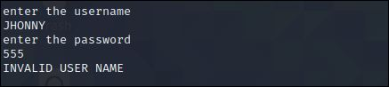

QUESTION 4 : Read a file name from the user. Check recursively whether it's a regular file and is empty and then remove the file. After verifying the removal, give a confirmation message.

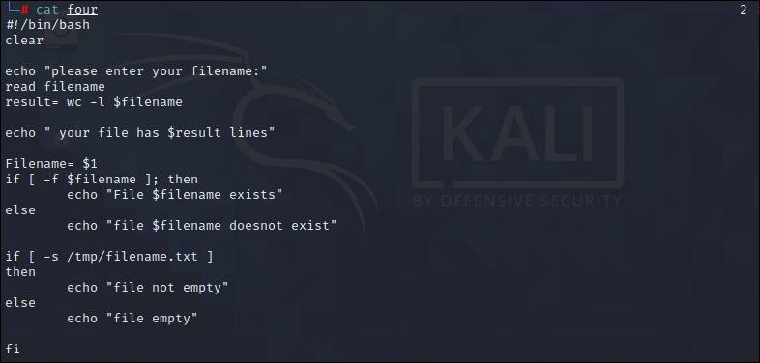

Output :

